**Checking filters present in filter icon.**

Step 1: Navigate to swag labs site using the URL - <https://www.saucedemo.com/>

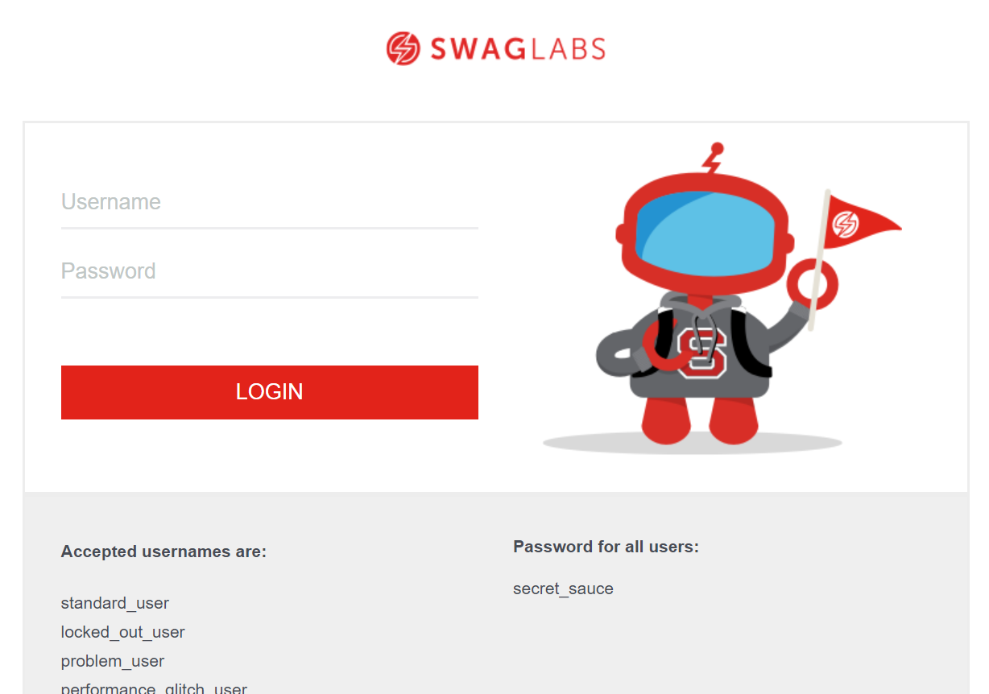

Step 2: Provide valid username and password and click login button. Given: Username= standard_user

Password= secret_sauce

Step 3: Click on filter icon



Step 4: Only below filters should be available in filter.

1. Price (low to high)

2. Price (high to low)

